Untitled

Zeynep Civelek

June 10, 2020

## R Markdown

This is an R Markdown document. Markdown is a simple formatting syntax for authoring HTML, PDF, and MS Word documents. For more details on using R Markdown see <http://rmarkdown.rstudio.com>.

When you click the **Knit** button a document will be generated that includes both content as well as the output of any embedded R code chunks within the document. You can embed an R code chunk like this:

## 'data.frame': 1088 obs. of 15 variables:  
## $ id : int 14 14 14 14 14 14 14 14 14 14 ...  
## $ age : int 5 5 5 5 5 5 5 5 5 5 ...  
## $ agemonths: num 62.9 62.9 62.9 62.9 62.9 ...  
## $ ageyears : num 5.24 5.24 5.24 5.24 5.24 ...  
## $ agecat : Factor w/ 3 levels "five","four",..: 1 1 1 1 1 1 1 1 1 1 ...  
## $ sex : int 1 1 1 1 1 1 1 1 1 1 ...  
## $ order : Factor w/ 2 levels "penfirst","stickerfirst": 1 1 1 1 1 1 1 1 1 1 ...  
## $ boxtype : Factor w/ 2 levels "blue-right","pink-right": 1 1 1 1 1 1 1 1 1 1 ...  
## $ trialtype: Factor w/ 2 levels "pen","sticker": 1 1 1 1 1 1 1 1 2 2 ...  
## $ order2 : int 1 1 1 1 1 1 1 1 2 2 ...  
## $ order3 : Factor w/ 2 levels "test","transfer": 1 1 1 1 1 1 1 1 2 2 ...  
## $ trialno : int 1 2 3 4 5 6 7 8 1 2 ...  
## $ side : Factor w/ 2 levels "L","R": 1 2 2 1 2 1 1 2 2 1 ...  
## $ response : Factor w/ 3 levels "","L","R": 3 2 2 3 2 3 3 2 3 2 ...  
## $ correct : int 1 1 1 1 1 1 1 1 1 1 ...

## [1] "id" "age" "agemonths" "ageyears" "agecat"   
## [6] "sex" "order" "boxtype" "trialtype" "order2"   
## [11] "order3" "trialno" "side" "response" "correct"

# We decided to use age as a continuous variable. The histogram shows the frequencies.

## [1] "five" "four" "three"

## 'data.frame': 1088 obs. of 15 variables:  
## $ id : int 14 14 14 14 14 14 14 14 14 14 ...  
## $ age : Factor w/ 3 levels "3","4","5": 3 3 3 3 3 3 3 3 3 3 ...  
## $ agemonths: num 62.9 62.9 62.9 62.9 62.9 ...  
## $ ageyears : num 5.24 5.24 5.24 5.24 5.24 ...  
## $ agecat : Factor w/ 3 levels "five","four",..: 1 1 1 1 1 1 1 1 1 1 ...  
## $ sex : int 1 1 1 1 1 1 1 1 1 1 ...  
## $ order : Factor w/ 2 levels "penfirst","stickerfirst": 1 1 1 1 1 1 1 1 1 1 ...  
## $ boxtype : Factor w/ 2 levels "blue-right","pink-right": 1 1 1 1 1 1 1 1 1 1 ...  
## $ trialtype: Factor w/ 2 levels "pen","sticker": 1 1 1 1 1 1 1 1 2 2 ...  
## $ order2 : int 1 1 1 1 1 1 1 1 2 2 ...  
## $ order3 : Factor w/ 2 levels "test","transfer": 1 1 1 1 1 1 1 1 2 2 ...  
## $ trialno : int 1 2 3 4 5 6 7 8 1 2 ...  
## $ side : Factor w/ 2 levels "L","R": 1 2 2 1 2 1 1 2 2 1 ...  
## $ response : Factor w/ 3 levels "","L","R": 3 2 2 3 2 3 3 2 3 2 ...  
## $ correct : int 1 1 1 1 1 1 1 1 1 1 ...

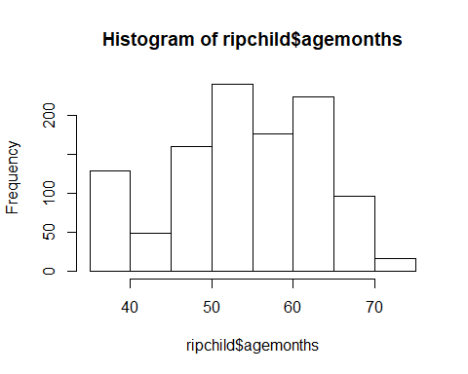

## Including Plots

You can also embed plots, for example:



Note that the echo = FALSE parameter was added to the code chunk to prevent printing of the R code that generated the plot.